Mama

Papa G

Oma

Uncle Ben

Gigi

Aunt Emily

Uncle Mark

Uncle Jake

G-pa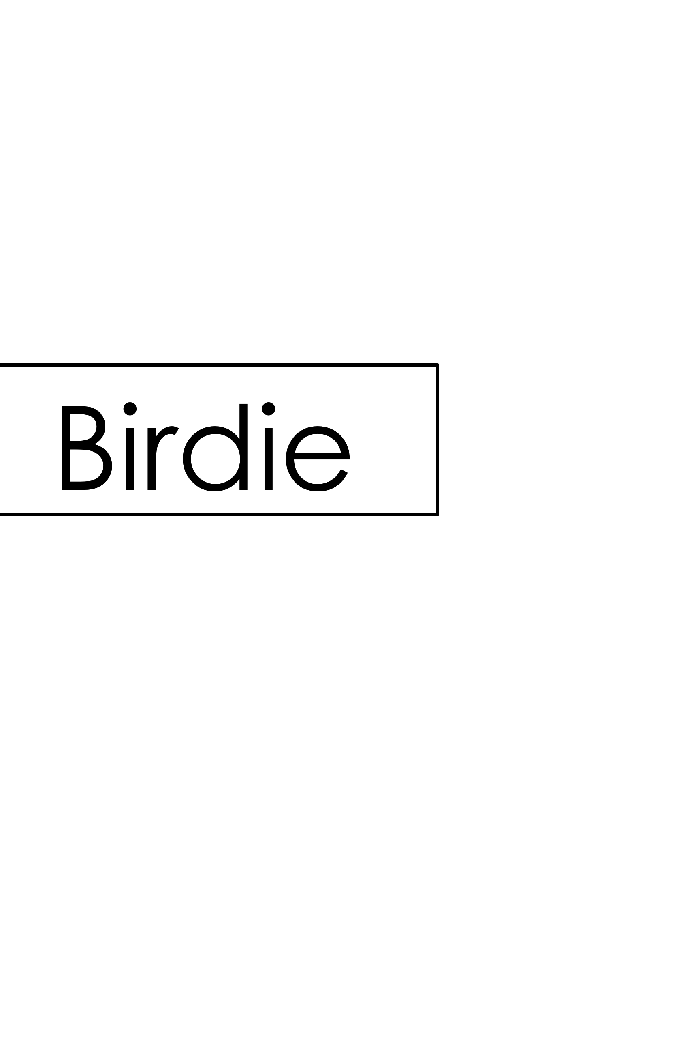

Birdie

Dada